Citizens’ Participation and Gamification – Lessons Learnt from Previous and Recent Participation Boosts in Germany
by Dr. Kai MASSER German Research Institute for Public Administration (GRIP) Speyer Lecturer, German University of Administrative Sciences Speyer and Dr. Linda MORY, Project Consultant at the Integration and Certification Center, SAP SE
Lecturer, German University of Administrative Sciences Speyer.

A
year ago, a newspaper article critiqued the citizen participation plans of two major German cities (FAZ, 19.02.2015). Its critique involved the following major conclusions: Damage of social capital. Opposing positions appear to be irreconcilable. Decisions are leaving deep wounds because of aggressive campaigns and non-objective discussions; Limited legitimacy of decisions because of low participation rates that include only special social groups. Minorities are dominating the majority of the people; Many present-day citizen groups consist of resentful people who only accept their own opinion; Elected representative bodies like the city council are disempowered
The article gives a focused summary of recent discussions regarding citizen participation in Germany. The advocates of direct democracy and citizen participation are using the same arguments, but achieving opposite results. Greater involvement of all parts of society could be achieved and problems could be solved in a more objective oriented manner (by deliberative mechanisms). Who is right and who is wrong?
The first paragraph of this paper deals with this issue. The second paragraph analyzes, how “gamification” can help overcome the “participation dilemma”.

§ 1 – Citizens’ Participation

The Participation Dilemma (in Germany): The More Possibilities There Are, the More the People Demand and Stay Absent
Nearly all German empirical surveys regarding attitudes towards democracy and participation agree in one respect: people want greater influence over the political decision-making. For instance, a nation-wide survey in 2011, based on a representative random sample. determined that 81% of the German Population desires greater political participation opportunities. Moreover, 60% declared their willingness to take part in participative processes outside of elections. (Nanz / Kamlage 2013, 12).
On the one hand, there are requests for more participation opportunities even though participation opportunities in Germany have become significantly larger over the last forty years.

Participation Boosts in Germany Since “1968”

In response to “1968,” a first “participation boost” took place in West Germany. All over the country, protest campaigns and citizens’ group movements increased after “1968”. More and more decisions of parliaments and municipality councils were called into question, and citizens requested more participation and involvement! Consequently, various hearing and consultation procedures and rights have been incorporated into the conventional political and administrative procedures (for example planning approvals and authorizations). It felt like a “participatory revolution” at that time (Geißel 2008, Vetter 2008, Masser 2010). Recent developments in the field include:
Freedom of Information Acts on the federal level and in 11 of the 16 federal states (2006ff.). By law, every person can demand official information (documents) without presuppositions.
The most recent amendment of the administrative procedure act (2013). Whenever a plan or a project might have a considerable impact on third parties, the responsible authority must inform the affected members of the public, non-conventional (deliberative) participatory mechanisms are required, and the affected public must be given the opportunity to react and respond to the plans before any decision is made in order that different alternatives could be considered. (Masser / Ritter / Ziekow 2014, 1ff.)
Beginning in the early nineties of the twentieth century, a second or “new wave” of participation opportunities arose that focused on the co-determination of citizens. (Very similar in many OECD-Countries):
Citizens’ initiatives and referendums at the municipal level, but also in federal states but with different quorums (petitioner and voter participation levels) and permitted issues, for example budget issues(!) are not allowed.
Direct ballot (sometimes recall as well) of mayors (in all federal states) and county commissioners (district administrators) (all non-city states except Baden-Württemberg).
In some federal states the opportunity to influence persons in the councils by choosing specific candidates from tickets (at the bottom the attempt to have electoral lists / the proportional voting sys-tem and the majority election system of single persons at the same time; very sophisticated).
In addition to those legally structured participation opportunities, there are extended possibilities for informal participation on all levels (Gabriel / Kersting 2014, 44). These aim to enhance citizen’s participation by involving citizens into political decision-making.
The direct ballot of mayors and county commissioners did not yield the expected success. Turnout rates were poor, very often below 50%; especially the turnout rates of second ballots are very low.
Moreover, in the state of Brandenburg, some elections of county commissioners were void due to low voter participation, less than 15%. Thus, especially in respect to district commissioners, direct ballots are called into question. It seems that people decide whether to vote according to the (personal) importance that they attach to the election. (Lückemeier, 12).

The Gap between Important Issues and Influence on the Decision-Making: “Were have all the Voters Gone”?

Klages and Vetter (2013) observe a widening gap between politics and the people (in Germany). If we look at turnout rates in Germany since 1945, there is a remarkable decreasing voter turnout, especially at the municipal level. At the state and in particular at the federal level, voter turnouts have cyclical fluctuations but have remained relatively stable. The turnout levels since the 1990 match the delineated order of importance (of the different hierarchical political levels) above (Figure 1) perfectly. Elections at the federal state level have the highest voter turnouts followed by the state level. Voter turnouts at the local and municipal level experienced a dramatic decline. (This concerns the elections for the European Parliament on a larger scale).

Figure 1: Election Turnout at Different Levels of Government in Hessen 1946-2010, percentages
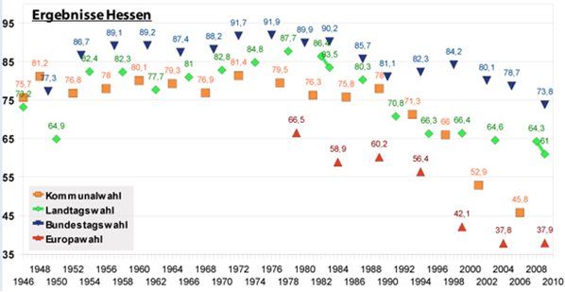
Municipal elections
State elections
Federal elections
European elections

Is it coincidence that voter turnouts at the municipal level dropped dramatically at the very time participation opportunities were expanded, especially at the municipal level and partly at the state level, but not at the federal level (second participatory boost)?
Since people had the opportunity for direct ballots (directly elect their mayor) and, pre-eminently, had the ability to decide by referendum (in Hessen at the municipal level since 1992) election turnouts declined dramatically. It appears that the more the people can immediately influence (political) decision making, the less important are the governing parties. On the other hand, federal elections have great importance, but people have no immediate influence on those elections (other than through the vote). In Germany, the people cannot directly elect persons at the state and federal level. Furthermore, at the federal state level referendums are not permitted.
Much of the approximately 80% of the German population who wish to have greater political participation opportunities (chap. 1) do not take part in elections, especially at the municipal level. Moreover, many of the 60% of the people, who declared their willingness to take part in participative processes outside of elections, do not take part in municipal elections. (We return to this very interesting issue later). Are elections just not enough in the sense that people want to have more influence on community issues?
There has been a recent “movement” towards participatory budgeting (PB) in many towns and cities in Germany. The underlying idea behind the PB is that the budget determines the municipal agenda (Bertelsmann-Stiftung 2004). Therefore, a PB seems to be a silver bullet that produces greater political participation which benefits administration and the citizens of communities. However, the bullet did not hit the target the first time. About twelve years ago, there was an attempt to introduce PB at the local government level. Six (relatively small) cities introduced PB on a pilot basis. The moment the state funding ended, four of the six cities stopped the pilot projects immediately. The reasons given by the municipal officials for terminating the project are significant:
Only twenty people attended the PB informational town meetings which is a poor ratio of (much) effort to (few) results.
The success of the PB was short-lived. Very quickly only the “usual suspects” (professional activists, “policy nerds”) were participating.
“No money: You should not ask citizens about their wishes and demands if there are no opportunities to put them into practice”. There was not enough financial scope for PB.
Retrospectively it looks like most of the PB1.0 approaches focused upon the delivery of information. Politicians and civil servants (concerned with budget matters) took the chance to comment and interpret the complicated matters of a public budget (together with the hardship of the day to day work of a civil servant) to the public. Supposedly, people did not want to receive lessons about the municipal budget in their leisure time. Moreover, the influence of citizens on the budget was very unclear or non-existent. The following chart indicates that something changed starting around the year 2010:

Figure 2: Number of municipalities introducing and continuing a PB in Germany, 2008-2013. Data Source: Status Report on Participatory Budgeting in Germany
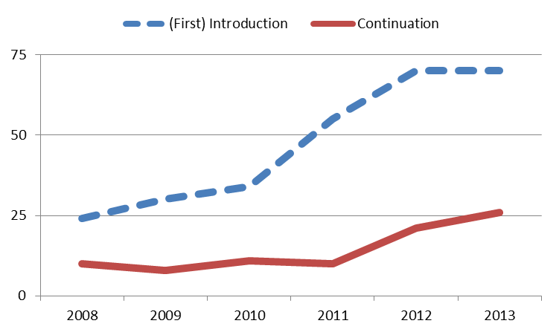

From 2008 to 2011 all municipalities which introduced a PB did not continue it the following year or, if they did, a corresponding number of municipalities quit the same year. Only about 10 municipalities continued their PB for a significant length of time. Since 2011, the number of municipalities to continue the PB has risen from 10 (2011) to 26 (2013). Although the number of municipalities (up to 70 in 2012/13) which discontinued PB rose at the same time (Due to a higher number of municipalities that introduced / tried the PB) there is a small but visible trend toward more municipalities using PB as a regular feature of city planning. (Nevertheless, compared with the approximately 2.000 cities in Germany, 26 is a rather small number).
At first sight, the reason for the turnaround can be attributed to Web2.0. More and more municipalities use Web2.0 applications to run their PB. On the other hand, Web2.0 was already being used by very ambitious citieslike Freiburg and Hamburg that use complicated PB approaches (see Figure 4). The use of Web2.0 appears not to be sufficient, by itself, to make PB flourish. In fact, the simplification and gamification of the concept seems to be the key to success. This goes without saying, that Web2.0 technologies support gamification greatly. A prominent and the most successful example of the new type of PB2.0 exists in the City of Potsdam (the capitol of the federal State of Brandenburg). PB Citizens can make and choose proposals that capture all kinds of projects and ideas. Every year (or now every two years due to the new bi-annual budget period), twenty proposals are selected for implementation. The concept is reminiscent of TV shows like “American Idol”: In the first step, proposals can be discussed and rated (for example by a “like-scale” from 1=very good to 5=very poor). From this a given number of the highest rated proposals remain, for example 100.
The second step is to have the highest rated proposals reviewed by the municipal administration and sometimes also by parliamentary groups (which have shown interest in the PB).
The proposals that “survive” the review process during the second step then occasionally go through another selection process: The short-list of proposals is rated a third time via the Internet (accompanied with mailed surveys), with every citizen able to vote on the proposals.
Then, finally, the city or town council must decide among the final remaining (20) proposals. If a PB-proposal is rejected by a municipal council, the reasons should be explained to the PB participants.
However, still only small groups of citizens take an interest in the PBs. Potsdam, the capitol of Brandenburg, attained the best result, 5% of the eligible voters took part.

Figure 3: Turn-Out-Rates of PBs, Participation-Method Differentiated (Source: Masser / Pistoia / Nitzsche (2013)
Number of Participants |  | Absolute Numbers |  |  |  | % of the Electorate
City | Year | "Face-to-Face"  Online Interview |  |  |  | "Face-to-Face"  Online Interview
Freiburg | 2009/10 | 206 | 1,861 | 2,575 | 0.13 |  | 1.22 | 1.68
Hamburg | 2009 | - | 552 | - | - |  | 0.04 | -
Marzahn-Hd. | 2007 | 50 | - | - | 0.02 |  | - | -
Potsdam | 2011 | 195 | 1,720 | 3,455 | 0.16 |  | 1.38 | 2.76
Trier | 2011 | - | 2,322 | - | - |  | 2.90 | -

If we look at the turnout rates for municipal referendums in Hessen, participation has been very volatile but sometimes reaches as high as 80%.

Figure 4: Turnout Rates of Municipal Referendums in Hessen, 1993-2013, percentages
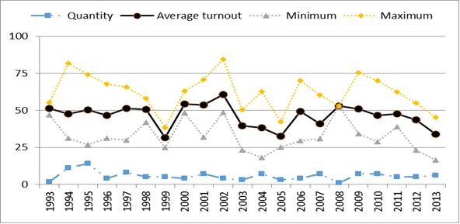
The average turnout rate is about 50%, which is more or less in line with the turnout rates for municipal elections in Hessen. In 1994, the highest turnout was above 75% and the lowest near 25%. In 2002, participation was very high, in 1999, 2005 and 2013, it was rather low. In 2013, there were 431 municipalities in Hessen. Referendums were held in less than ten of the municipalities since 1995. To prevent low participation in Switzerland, all referendums are jointly executed (at four fixed) dates. In Germany, it is exception that referenda are executed on the same date as elections or other referenda. Therefore, participation is more volatile than in Switzerland because, when there is just a single referendum (and not a few at all levels of government), participation depends much more upon whether people are interested in the subject. (Masser / Mory 2014, 11). Turnout Rates for (scarce) state referendums in Hessen demonstrate the same pattern. A participation of 81% seems to be the upper limit.
The following conclusions can be reached regarding participation in Germany: Approximately 20% of the people want to participate at all.
The majority of people only become active and take action if it seems significant or they are personally concerned (e.g., their property is affected).
In conclusion, the participation dilemma is apparent. On the one hand, there seems to be a disparity between which matters people want to decide and whether it is permissible. The political elites (parties) are not willing to give people more influence at the (federal) state level. However, most of the people consider that the most significant decisions are being made at the federal government level. Furthermore, most participation offers concern the area of local planning. Without the power to decide, it is therefore not paradoxical that people do not use the existing participation offers even though they demand more participation opportunities.

The Participation Dilemma (in Germany) 2: “You Can't Always Get What You Want … But Do You Get What You Need”?
A societal value change occurred in all OECD countries over the last century. Klages (2001) sums up the societal value change by the formula “a shift from the performance of one’s duty and obedience to self-expression and development”.

Figure 5: Change of Educational Goals in the German Population, 1951-2001
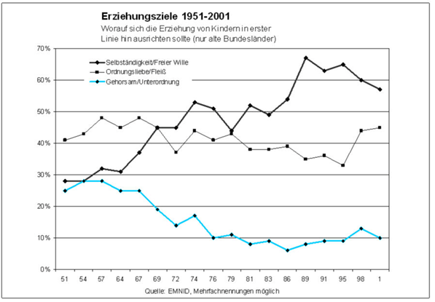
Educational Goals 1951-2001
What is most important in education? (Only Western German States)
authonomy / free decisions
orderliness / diligence
obedience / subordination
However, the general thrust of the societal value change is grounded in a need for personal independence and individual opportunities of action which result in a need to (co-)decide on matters concerning one’s own affairs (see Klages/Vetter 2013, 18). The taking-over of tasks, commitment and motivation is based upon own views, thoughts, values and belief.

The Economy of Citizens’ Participation: Political Participation is Not the First Choice (of Self-Actualization)

The city of Mannheim (MA) complied a “democracy audit” in 2013 based on a representative survey among citizens (Van Deth / Schmitt-Beck / Odrakiewicz, 2013). We, the German research institute for public administration (FöV) did a similar survey in 2014 on behalf of the city of Gießen (GI). Both surveys contained a question about civic virtues. The respondents could grade their judgement of a list of virtues on a scale from “very important” to “totally unimportant”.

Figure 6: Judgement of Civic Virtues (Two Democracy Audits in German Cities), average (arithmetic mean)
0 “totally unimportant” / 10 “very important”

Apparently, people view political activity or involvement as much less important than participation in elections. This is in line with our findings in chapter 2.2. (see also Ewen / Gabriel / Ziekow, 2013, 102) People participate in elections or referenda in large numbers, but do not participate in significant numbers in other, more intensive and time consuming participation measures. Many studies on volunteer involvement have shown that very few citizens do volunteer work in the political arena (Klages / Masser 2009, 38ff.). Compared to areas like religion or sports, political volunteering can often be very time consuming.
According to the findings of our empirical surveys (citizens’ surveys), there are two (in fact, three) major determinants of citizen participation:
– The effectiveness of a participation mechanism, that is how binding are the results and how much influence do participants have.
– The cost of involvement, especially the time requirement, and the inconvenience which includes peer pressure and the uncertainties involved in dealing with political activists.
There is a big gap between the rather high estimates regarding the effectiveness of involvement in political parties and planning processes, and the low numbers of people who actually become members or contribute. (The percentage of Germans who are members of political parties is below 3% (Masser 2013, 317)). Participation increases when a mechanism catches the attention of the media, but his often does not happen.

Figure 7: Turnout and Effectiveness of Participation Instruments, Democracy Audit Gießen 2014, percentages

The most popular forms of citizen participation involve surveys, signature collection, boycott of products and voting which can be very effective, but do not require much time or higher education. Referendums are very popular as well. (Klages / Masser 2009, 51). The success of citizen participation, that is the number of citizens who participate, is dependent on how citizens evaluate the cost-benefit of participation.

Selective Utilitarianism and Political Activism: Different Behavior and Different Expectations

Citizen surveys carried out by the German Research Institute for Public Administration (GRIP) Speyer consist of two independent components: a random sample of personally addressed people and an online survey that is open to everyone. The latter group self-recruits based on its interest in the subject matter of the survey. There are big differences between the two groups. Participants in the open survey group tend to be older, male dominated, have a higher level of education, and tend to be more voluntarily active and more interested in politics. (Klages / Masser 2009).

Figure 8: Citizen Participation Involvement of Representative and Politically Active (open survey) Groups, Democracy Audit Gießen 2014, percentages

The higher participation that results from the open survey involves people who are more active in online consultations, more likely to contact politicians and the administration, engage in citizens’ initiatives, and involve themselves in signature collection campaigns.
In a representative democracy, the economy of citizen participation by political activists does not seem to be advantageous. These people spend lots of time and efforts for example on online forums, citizen initiatives and so on, but do not have significantly more power than any other citizen. This is nor desirable because the benefits (decisions) are not in line with the costs. In other words, political volunteer involvement has a poor cost-efficiency ratio except for those who have power. This may explain why political activists are dissatisfied with the political system, particularly in Germany. On the hand, the majority of people benefit. The division of labor between government and administration, and the citizen, together with the opportunity to have significant influence in elections and referendums, seem to be very attractive because of a very good cost-benefit ratio (less time and effort, but rather high influence). Therefore, the German political system seems to be in line with the needs of the majority of the people. Without doubt, most of the people would appreciate more influence without significantly more effort.

§ 2 – Gamification

Engaging People by Letting Them have Fun
In recent years, the term “gamification” has been used more frequently. Gamification is a concept that applies to the participation of customers, employees or even citizens. As with many new concepts, the meaning and content of the term is unclear in the beginning. (see Shah (2012), p. 1). In our understanding, gamification focuses on engaging people and examining what motivates and interests them, and providing them with playful experiences that benefit the players, as well as everyone else such as companies, customers, co-workers, administrations and government – depending on how gamification is used.
A formal and widely used definition of the term is provided by Deterding et al. (2011) who defines gamification as “the use of game design elements in non-game contexts” (p. 1). There are other definitions, as well, including one from Shah (2012) who defines the term as “[…] a way of using game mechanics (namely competitive challenges, recognition and rewards) to improve a business process, with the goal of fulfilling business objectives” (p. 1). All of the definitions have in common the basic idea of using game thinking and game mechanics to engage users in solving problems. Gamification can be used to improve user engagement, return on investment, data quality, timeliness and learning. The techniques of gamification include giving rewards to users who complete certain tasks, foster competition and fundamentally make tasks feel like games.
As Shah (2012) points out there are four main elements of gamification systems (p. 1):
– Objective: First, it is crucial to identify the business objective in order to know what the organization is trying to achieve. For example, the goal may be to improve adoption rates, to encourage employee learning, to improve brand awareness, to shorten processes and so on
– Mission: The mission breaks down the business objective and provides a set of related task designed to achieve the business objective. It can have different levels, and players can be rewarded for completion of each level or mission
– Gaming Components: The gaming component can involve badges, levels, challenges, leader boards and players
– Well-thought-out design: An effective and well-suited design is one of the most important part of the gamification process. In this regard, ease of use and an intuitive design are crucial for the overall success of the process
In order to be successful with gamification a player-centered design requires knowledge of the players, identification of the business objective and mission, an understanding of human motivation, and application of mechanics among other themes. In the private sector (sometimes as well as in the public sector) good examples can be found.

How the Private Sector is Playing Games

Gamification is inspired by the video game industry. This industry serves as the thought leaders in discussions regarding gamification in the private sector,especially the software industry. There is one rule for game developers at EA Games, the makers of the popular Madden NFL video game series among others: Game software must produce visible joy for the user within seven minutes or it will be a flop.
When SAP started to re-think its approach to software development a couple of years ago, the company looked at the video game industry for inspiration. In this regard the question from employees was raised: Does this mean we can all look forward to using a “Killzone 3″-like interface to enter our travel expenses? The answer is “not exactly”, but the general idea behind video game mechanism and intrinsic motivation is very similar. Video games mean big business and SAP came to the conclusion that enterprise software developers can learn a lot from the emotional connection gamers make with the likes of the Killzone 3, which sold over 500,000 copies in its first week of release in North America.
In chapter 2.2 we explained how a game show concept (e.g., American Idol) re-animated and saved the participatory budgeting (PB) process in Germany. The mentioned company SAP uses exactly the same concept to improve its products (software). There are striking similarities between the goals of the two approaches: to improve existing software and enhance the functionality of a program named “Customer Connection”. Users (customers) are encouraged to post improvement requests and other suggestions on the SAP Customer Influence Platform. Requests and suggestions are discussed in customer groups or special interest groups in an effort to “collaborate with as many customers as possible and retrieve a ranked backlog (the idea is passed to SAP Development to be evaluated) based upon customer needs”. The “players” act in different roles: 1) “Request Owners” submit and describe their idea. 2) Subscribers “vote” for the idea and thus help prioritize an idea to qualify it for the backlog analysis by the company (minimum of 5 subscriptions per request); 3) Followers become informed about the progress of the “idea” and make comments on it. (Customers receive feedback about whether and how the idea will be implemented or the reasons why the idea cannot be realized in the current project. Selected improvements are provided as Service Packs & Enhancement Packages). Customers can therefore use “Customer Connection” specifically to:
– Submit improvement requests,
– Discuss and subscribe to submitted improvement requests,
– Track the status of the improvement requests relevant to them
– State whether they want to implement improvements, and if so, which ones.
The company reports that customer requests triggered almost 400 product improvements and that more than 6,500 customers worldwide have made use of the process. Customers and citizens perform the same function: the improvement of software products they use, and evaluation and development of public policies and projects. In both cases, we see the same process of obtaining feedback about a system from its environment. In evolutionary terms, we could speak of smart adaption. What is really amazing, however, is that there are three identical roles: 1) The facilitator who is in charge of establishing the “setup defaults” and the rules of the game. 2) The (small group of) active users, customers or citizens, who make requests and proposals and participate in the discussions. 3) The “interested audiences” who vote for or against “the stuff” (thumbs up, thumbs down). It almost seems that these three same groups are an eternal part of both democracy and client orientation. We find them in ancient Greece in Athens which had: 1) Facilitating official bodies. 2) Particular citizen-prosecutors who take the initiative. 3) The polity: Thumbs up / thumbs down. (Literally used in the “panem et circenses” games in ancient Rome).
However, what we learn from the Customer Relation strategy of SAP and the evolution of PB in Germany is, that people are not interested in being involved in complicated details like the drawing up of a budget or the development of a software (programming of code), but rather in outputs and outcomes. Moreover, the different groups of users/citizens have different demands regarding how they want to be addressed. However, we see that customer involvement and citizen participation seems to be more successful if the procedures imply entertainment, suspense and kick. Free democratic elections are not only fair and just, they provide entertainment and suspense to the civil audience. The primary elections in the USA are a good example: Who will be the candidates? There are a series of TV-debates in both major parties and a lot of other media attention even if it is just the primaries.
Another way to produce gamification is through (group) challenges.
During the “Bankathon,” awards are given for the best new developed and designed financial products. Within thirty hours, teams must develop new creative ideas for digitalization in the financial industry. The best solutions get an award, inter alia start-up coaching hosted by SAP.

How the Public Sector is Playing Games

Whereas the private sector is already using gamification for business purposes, the public sector is only beginning to exploit gamification for their own purposes and needs. However, there are also some good examples from the public sector which show how gamification can be used to stimulate citizen participation. One is in the municipality Ludwigshafen in Germany where we started a project on renovation of the elevated highway “north”. The elevated highway “north” in Ludwigshafen (at the Rhine) was built between 1970 and 1980 and needs complete renovation now. It is a national road which begins as a freeway, goes through the centre of the city, and crosses the Rhine (see Figure 1 below).

Figure 9: Elevated highway “north” in Ludwigshafen am Rhein, Joystick to drive through the 4 scenarios
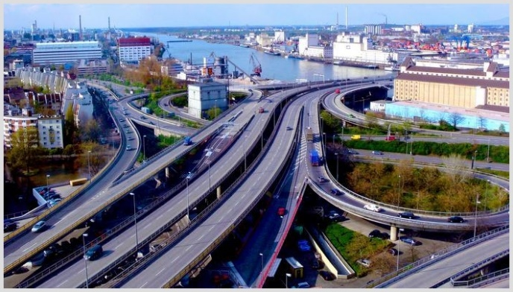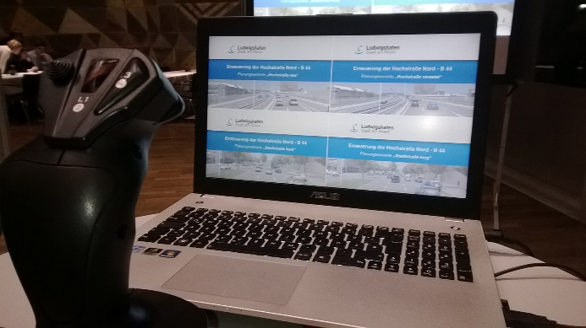

The building project will have a major impact on the city and the region. The construction will take approximately 10 years and cost approximately 300.000.000 Euro. The city decided to involve the population at an early stage of the process. Like in another similar case in Germany, renovation of the A 6, four alternative planning variants were developed. The solutions varied from a complete re-establishment of the elevated road, two half-elevated versions, and a completely new “ordinary” road at ground level. During town hall meetings and on the web, the variants were presented and the specifications were explained: How long will the construction last (eight to twelve years)? How much will it cost ( € 270 Mill. to € 330 Mill.)? How much noise and exhaust emissions will be created? What possibilities exist for future development of the city under each of the scenarios?
An outstanding feature of the process involves the fact that the city created virtual 3D-videos for all four scenarios, and these videos were presented at town hall meetings and on the web. Thus, every citizen could drive through the virtual new roads, balance the pros and cons, and state his/her preferences regarding the alternatives. Within an online-consultation platform, citizens could make comments on the project and discuss issues with each other. Finally, participants could vote for one of the four options. In most respects (costs, possibilities for city development, and so on) about three out of four of the participants opted for the new road at ground level. In principle, the city council bears responsibility for the decision.
However, it seems nearly impossible for the council to decide against the clear intention of a majority of citizens. More than 10.000 people took part in the town hall meetings and particularly the online-consultation. Even if a group of citizens still prefers an elevated highway (especially if traffic flow and parking space are preferred goals), the majority has chosen in favour of the ground level road. Resistance by a citizens’ initiative will stand no chance.
The example of the elevated highway “north” in Ludwigshafen shows that, when there are (potentially) conflicting goals, early stage citizen involvement is insufficient.
It is important to encourage broad involvement of a large number of (relevant) citizens which was achieved through a gamification approach in the case of Ludwigshafen. The case shows that a simple participation method and procedure with clear elements and a defined outcome are very helpful in reaching the overall goal. Additionally, visualization (3D animation) helps translate complicated planning for laymen. Today, various kinds of planning software are available. Regardless of whether one wants to plan a new house or a garden,.3D simulation makes it possible to depict everything in a “game scenario”.

Figure 10: Example planning software “traffic simulation by PTV vissim”
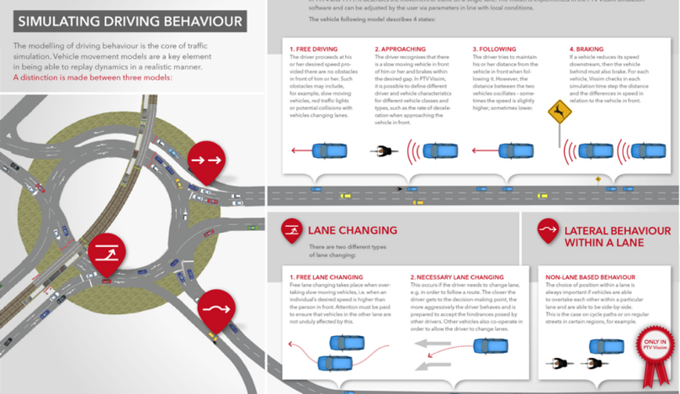

With the help an appropriate software, it might be possible to integrate citizens into the planning of large-scale projects through multiplayer online games. The task of planning is to determine the right setting for the game. It is necessary, for example, to define possible courses of a road, possible locations for a plant, minimum or expected capacity and so on. Gamification changes the way information is presented. The classical form of (long) written texts, extensive tables (with figures), and construction drawings are not appropriate ways to give citizens understandable information. For example, administrative information should be translated by (digital) visualization and compression into pictures/videos and significant indicators. This transformed information is the basis for the development of games.
One of the favourable features of the winning scenario in Ludwigshafen was the enhancement of city-development opportunities, in particular free spaces for new buildings or green corridors. On other hand, in the 3D-animation, there were only vague cubes and potential solutions. What the future will bring is still open. Many cases of city development planning in the past (for example of the 60ies and 70ies) did not provide the desired results. Instead of modern and vital neighbourhood’s social flashpoints developed. To determine the risks and potentials of different approaches, future development can rely on gamification. Like for example in the marshmallow challenge, different groups could virtually develop the city. Every group gets the same set of resources and restrictions.
Browsergames like “Forge of Empires” already take an interesting approach. The course and outputs of the games (challenges) could deliver valuable information about mistakes to avoid and factors to encourage.
Another example of how games can be used in the public sector is that of the “Forest Echo”, a pilot project of the forest administration of the state of Rhineland-Palatinate. (Rhineland-Palatinate is – with 42% of forest area – the German state with the most trees as a percentage of total landmass.) “Forrest Echo” is the adaptation of a very common system of citizens’ management concerns in Germany called the “defect reporter” which is quite similar to the British “FixMyStreet” Web-Platform. Responsible administrations receive information in the form of complaints. By the use of geographical data, it is possible to visualize the location of a problem and thus, present it to the (internet) public. Moreover, it is possible to monitor the resolution of the problem. In the “Forest Echo”, digitization entered the woods, revealing typical complaint such as fallen trees / branches, animal carcasses and illegal dumping (besides the usual “off-topic” overall political stuff).

Figure 11: Typical issues “Forrest Echo”, reported by citizens
Soon after the launch of the project, the project was a huge success in one of the four pilot areas. The four pilot areas were Trier (northwest), Mainz (northeast), Kaiserslautern (central) and “Haardt” (central/east). Very early in 2016, one of the project areas (Kaiserslautern (K-Town)) received the most attention. This was unexpected. The following map from the 1.05.2016 illustrates that public attention focused upon the forestry office of K-Town (26 of total 30 actual cases are pertaining to K-Town). Explanatory approaches were used in the area of K-Town, showing that the forest might have a higher significance to the people. Then, the local newspaper reported about the “Forest Echo” and a multiplier effect resulted. Thus, even if there was no intention to use the “Forest Echo” as a game, it transformed into one.

Figure 12: Spatial distribution of Reports
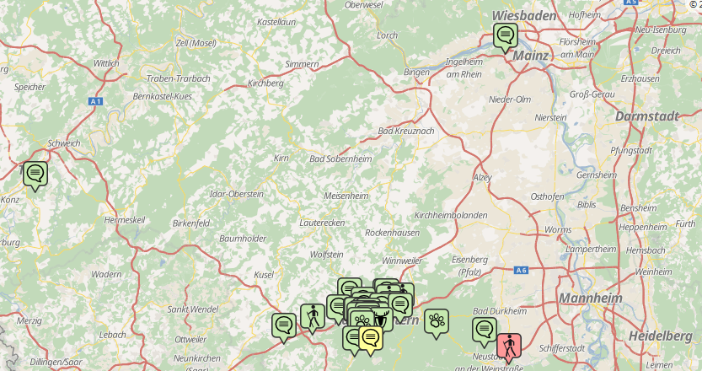
Almost all games depend upon suspense and a sufficient (number of) participants. The “defect reporter” is on the publication of the reports and everyone can watch the progress. The “Forest Echo” used four stages, marked by traffic light colors: 1) incoming / not verified (red), 2) in process (yellow) and 3) solved (green). In K-Town, forest administration tried to solve all reported problems quickly. They knew that there were many viewers and thus, staff was highly motivated. By contrast, in “Haardt” there were one of two reported problems that work did not state on for more than a month. Due to the huge “success” of K-Town. and the very few complaints and reports, the other three districts lost interest (in the game). It was as if one team wins all matches in a league 10:0, year after year. The losers lose interest, subsequently no audience can be attracted.
The question therefore is how the responsible authority (ministry) can “restart” the project. That is, how can it reshape the setting and the rules of the game in order to encourage all four project areas to participate again. Many other problems e.g. reorganization within organizations or regulatory impact analysis could be analyzed by the help of seeing them as “games”.

Conclusion
In society, people want to (co-)decide political matters. A vast majority of German people demand more opportunities to influence political decisions. At the same time, people have considerable distrust of politicians and political parties. Thus, the majority of the (German) people do not want to get enmeshed in policymaking processes. In general people accept the idea that a small elite of politicians and bureaucrats are doing the complex and time consuming business of government and administration. Most of the time, the division of labor between citizens and government and administration works well. The majority of the people (about 65-75%) want to be informed about (all) public issues in order to interfere if necessary (act as veto-players). Additionally, there is a group of approximately 10-15% of the people, who want to be permanently involved in political decision making outside of parliaments and councils. Participating budgeting and the planning of large scale infrastructure projects serve as examples of the ways in which gamification can serve as an instrument for meeting the demands and requirements of different groups in a modern pluralistic society:
– (Elected) political bodies, public officials and professional experts: They remain in charge and responsible as decision-makers, but their roles change. Consultation of citizens is becoming a part of decision-making and thus is being translated into action. Gamification is a convenient measure for involving citizens. By defining the setting and the rules of “the game”, officials do not lose their decisive (legal) function. On the contrary, gamification enhances control over the implementation of political decisions by getting feedback about possible and actual deviations of planned outcomes. If enough people take part, legitimacy is enhanced.
– The group of (politically) active citizens: This group includes preponderantly male members with income and education above the average and retired persons. Without being elected, and without any kind of appointment, these persons demand to represent “the people”. Gamification provides an opportunity to this group to be active and play a significant (but time-consuming) part in public affairs. This can cover the search and discussion for public investments or budget savings as well as (the testing of) alternative planning of infrastructure projects. With the help of gamification, it is possible to test and elaborate municipal policy programs. The playing out of (different) projects under different settings and conditions, opportunities and risks become visible. As in the case of quality management in private business, gamification has the potential to improve public goods with the help of the “customers”
– The majority of “the citizens”: This group does not want to become politically active in the sense of “face-to-face meetings”. On the other hand, people do want to have information about all significant public issues and have the authority to co-decide if necessary. Therefore, all kinds of voting procedures are appropriate to fulfil this need even if they only “like” or “dislike” a proposal or an opinion. It is helpful when they provide ratings regarding the advantages and disadvantages of alternative solutions and scenarios (public investments, infrastructure projects, savings and so on). All in all, the majority is involved through voting procedures even though they are not able to make the final decisions. Additionally, people do not have to spend much of their time
The development of alternative scenarios and solutions is possible through the help of a group of active citizens. The setting of goals, rules and framework is the inevitable task of political officials and professional experts. People can, however, provide input regarding the pros and cons of different proposed solutions (developed by games). The decisive factor of games (and gamification) helps administrators make decisions, but still leaves room for governmental officials to use their judgment.

http://www.faz.net/aktuell/politik/inland/gruende-gegen-direkte-demokratie-auf-kommunaler-ebene-13432408.html.
Information also available from: http://www.bertelsmann-stiftung.de/de/presse-startpunkt/presse/pressemitteilungen/pressemitteilung/pid/umfrage-buerger-wollen-sich-an-politik-beteiligen/?tx_rsmbstpress_pi2[page]=28&cHash=00c77b5fe68ff8e349dda5f81161dc0a [accessed 27 April 2015].
See for example http://www.statistik-mv.de/cms2/STAM_prod/STAM/de/start/_Landeswahlleiter/Landeswahlleiter/kommunalwahlen/Direktwahlen/index.jsp [accessed 28 April 2015].
See for example http://www.wahlen.brandenburg.de/sixcms/detail.php/bb1.c.191073.de [accessed 28 April 2015].
See for example http://www.sr-online.de/sronline/nachrichten/politik_wirtschaft/buergermeister_wahlen_luckas_parteien100~print.html [accessed 28 April 2015].
Source: State Returning Officer, available from: www.wahlen.hessen.de [accessed 2 April 2015].
The Website “buergerhaushalt.org/en” monitors PB activities in Germany.
See http://www.buergerhaushalt.org/en/statusberichte. The website monitors the development of BP in Germany permanently.
At a first glance a lucid explanation, see Masser, K., Pistoia, A. und Ph. Nitzsche, 2013.
In GB „Pop Idol“, in Germany „Deutschland sucht den Superstar“.
Source: Statistical Office of the Federal State, available from: http://www.statistik-hessen.de/themenauswahl/wahlen/daten/nach-gemeinde/index.html [accessed 2 April 2015].
Source: State Returning Officer, available from: http://www.wahlen.hessen.de/irj/Wahlen_Internet?cid=1cf3c4ce36580e81f03f670ddf1edf78 [accessed 2 April 2015].
Based on annual representative sample surveys of the German population from 1951 to 2001 by the renowned EMNID-Research Institute (Masser and Mory 2014).
Mannheim is a regional center in a metropolitan area (Rhein-Neckar) with approximately 315 000 inhabitants. Gießen is a university city with approximately 80 000 inhabitants.
The Speyer citizens panel is documented in several research reports (published by GRIP), available (in German) as downloads: http://www.foev-speyer.de/publikationen/pubdb.asp?reihen_id=1.
https://influence.sap.com/ct/c_f.bix
See for example https://www.bankathon.net/#results_menu
Everything about the project and the road: http://www.ludwigshafen.de/nachhaltig/city-west/.
The final report of the participation process is published here: http://www.ludwigshafen.de/fileadmin/Websites/Stadt_Ludwigshafen/Nachhaltig/City_West/Buergerbeteiligung/LU_Auswertungsbericht_Stand20140317_final.pdf.
Try https://ludwigshafen-diskutiert.de/.
http://marshmallowchallenge.com/Welcome.html.
https://en.forgeofempires.com/.
https://www.fixmystreet.com/: „FixMyStreet is an application that allows citizens inform local authorities of problems that need to be addressed in their neighbourhood (broken streetlights, potholes, poor lighting, unsafe streets, etc...) with the help of a map.”

