Financial Transparency of Local Governments in Easter EU Countries
by Miroslav Ivanov – Junior Auditor, Bulgarian National Audit Office, Sofia, Bulgaria, Ph.D. candidate, Faculty of Economics and Business Administration, University of Zaragozam Zaragoza, Spain;
Vicente Pina, Ph. D. – Full Professor of Accounting and Finance, Faculty of Economics and Business Administration, University of Zaragoza, Zaragoza, Spain;
Lourdes Torres, Ph. D. – Full Professor of Accounting and Finance, Faculty of Economics and Business Administration, University of Zaragoza, Zaragoza, Spain.

T
he dynamic political and economic processes existing in Eastern EU countries in recent decades have resulted in significantly increased attention to transparency and accountability issues in the public sector, particularly in regard to financial issues. Citizens, taxpayers, donors, lenders, the EU and other supranational institutions have been interested in obtaining high-quality financial information that will allow them to assess how public funds are being used, as well as the performance of public sector entities. They wish to use this information to hold managers accountable, as well as in their own decision-making processes. According to Chan (2003) “it is not enough to keep the book accurately; the books have to be open to the public. [Government accounting] aims at keeping the citizens informed about the city’s financial position, financial performance and service effort and accomplishment, which is crucial information to determine the affordability and sustainability of service delivery and value for money issues.”
Transparency and accountability are mutually related notions. Transparency is usually related to openness, and is designed to provide easy access to accurate, reliable and clear information. Accountability is a result of transparency, and requires governmental officials to assume responsibility and liability for the decisions they make, and to provide explanations. For Freed (2011) “in a democracy, citizens’ perceptions define reality, and transparency’s success or failure should be first and foremost defined by citizen opinion.” Tanzi (1998) explains that the lack of transparency leads to national corruption in investment projects, in procurement spending and in extra-budgetary accounts. Transparency and accountability are, therefore, vital preconditions for ensuring efficient and effective allocation of public resources and improving social welfare.
In an effort to respond to the increased demand for transparency and accountability, Eastern EU governments have initiated a wide range of reforms aimed at improving the quality of financial information. The main source of such information is the general purposes financial statements (GPFSs). Financial reporting transparency is directly correlated to the quality of the information presented in the GPFSs. In October 2014, the International Public Sector Accounting Standards Board (IPSASB) of IFAC issued a document entitled Conceptual Framework for General Purpose Financial Reporting (Conceptual Framework) by Public Sector Entities, which provides guidance for issues not dealt with by IPSASs or the Recommended Practice Guidelines (RPGs). Under the Conceptual Framework, in order to determine the quality of the financial information provided, one must look at the relevance of the information provided, as well as whether it provides a faithful representation, is understandable, is timely, comparable, and verifiable. Transparency is achieved when the foregoing characteristics are fulfilled.
The essential challenge for Eastern EU countries is to shift from a cash basis to an accrual basis of accounting. The difference between these two approaches is in the moment of recognition of transactions and other events in financial statements. When cash basis of accounting is applied, entities recognise economic transactions and other events when money or its equivalent is paid or received. By contrast, accrual accounting requires entities to recognise economic transaction at the moment that they occur. The main benefit of accrual basis financial reporting by governments is that financial reports provide information about the future economic and financial consequences of decisions taken now, and therefore provide more useful information about governments’ financial position and financial performance. By contrast, with cash accounting, the focus is on monitoring inflows and outflows in the short term for compliance with legality purposes.
This paper analyses the contributions of accrual accounting to financial transparency and accountability. The study is based on the GPFSs of 50 Eastern EU local governments, and the general concepts that underlie their preparation under IPSASs. The first section of the paper includes a short description of the reforms undertaken in Eastern EU countries, and the importance of accrual accounting for improving transparency and accountability. The second section explains the methodology applied. The third contains data analysis, and the fourth discusses the results and conclusions.

§ 1 – Theoretical and institutional context
Local governments directly provide public services to the citizens. In this sense, local governments are “closer” to the citizens. Furthermore, local governments manage large amounts of public resources. All Eastern EU countries (in particular the local governments) are beneficiaries of the European Cohesion Fund and other EU funds.
Before changes in the political system of Eastern EU countries that took place in 1989, public sector accounting was designed simply to provide the information needed by central planning authorities. This information was used to evaluate and control budget expenditures, prepare multi-annual plans and preserve public property. During this period, financial reporting did not provide fair and true information on public sector entities’ financial positions, their performance or their economic transactions. Moreover, financial statements were not published and citizens were not aware of government expense or revenue streams.
At present, all Eastern EU countries have instituted major reforms in an effort to introduce the principles of market economies and democracy into their systems. These reforms have affected all levels of society, particularly the public sector and its accounting system. While some of the reforms were driven by internal socio-economical pressures, others were required by EU membership requirements. The main purposes of these public sector accounting reforms were to improve the quality of financial information, provide an improved basis for state budgeting and decision-making, increase transparency and accountability, provide a thorough review of public entities’ activities and property and win the trust and the confidence of the citizenry. Accrual accounting has provided a key mechanism for achieving transparency and accountability. However, different countries have reached different levels in the implementation of accrual accounting.
An important element of transparency is the type of financial reporting framework that is used, be it a “fair presentation framework” or a “compliance framework”. Although a fair presentation framework requires compliance with a set of requirements, it acknowledges the need for a fair presentation that involves disclosures beyond those that must be provided. In other words, this framework may require a departure from the established framework. IPSASs provide an example of a fair presentation framework. A compliance framework requires reporting entities to adhere to a set of requirements, but does not require supplementary disclosures or departures from the framework requirements. All Eastern EU countries have developed and adopted fair presentation frameworks.
Various supranational bodies, including the IFAC, European Commission (EC) and International Monetary Fund (IMF), have all required Eastern EU countries to shift to an accrual basis of accounting. In 2011, the Council of the European Union introduced Directive 2011/85/EU, which sets up requirements for the budgetary frameworks of member states. The Directive concerns public accounting systems, and requires transparency through the application of an accrual basis of accounting (Article 3). Member states were obliged to transpose in their domestic legislation the requirements of this Directive.

§ 2 – Methodoly
The data for our research was derived from the legal accounting requirements and the annual financial statements published by 50 EU local governments in 2011. When the necessary information was not available on a city’s web site, it was requested from the city by letter. 108 letters were sent and 72 answers were received, so that a total of 83 annual financial reports were available to us. In the case of Bulgaria, requests for access to public information were sent to 7 local governments. All letters were sent in the official language of each country. The local governments studied in alphabetic order by country are as follows: Sofia, Plovdiv, Bourgas, Stara Zagora and Pleven in Bulgaria; Brno, Ostrava, Liberec, Ceske Budejovice and Pardubice in the Czech Republic; Tallinn, Tartu, Narva, Pärnu and Kohtla-Järve in Estonia; Budapest, Debrecen, Miskolc, Gyor and Kecskemet in Hungary; Riga, Daugavpils, Liepaja, Ventspils and Valmiera in Latvia; Vilnius, Kaunas, Klaipeda, Panevėžys and Alytus in Lithuania; Warsaw, Krakow, Lodz, Wroclaw and Lublin in Poland; Bucharest, Cluj-Napoca, Iasi, Constanta and Galati in Romania; Bratislava, Presov, Zilina, Nitra and Trnava in Slovakia; Ljubljana, Maribor, Celje, Kranj and Novo Mesto in Slovenia. In the sample, the city with the smallest population was Valmiera (Latvia) with 25,130 inhabitants in 2011, and the city with the biggest population was Bucharest (Romania) with 1,883,425 inhabitants in 2011.
The problem of language presented an additional difficulty for this project. The majority of Eastern EU local governments publish GPFSs only in their domestic language, and therefore we were forced to deal with 10 different languages.
This empirical work measures the degree to which Eastern EU local governments have implemented accrual accounting best practices. It does so through a comparison between the domestic legislation of each country, the actual financial statements published by local governments, and with the requirements of the IPSASs of the IFAC.

§ 3 – Analysis of results
Table 1 highlights the differences between the legislative frameworks for public sector accounting applied by each country at the local level. The table uses as a benchmark the requirements of IPSAS 1 – Presentation of Financial Statements, and reveals the degree of implementation of IPSAS 1 requirements in domestic accounting regulation, and the actual financial statements published through the classifications “1”, “2”, “3” and “0”. The classification “1” is used when a financial statement (or a general concept) required by IPSAS is presented (or applied), and it is in compliance with the relevant legislative accounting framework; “2” is used when a financial statement (or a general concept) is not required but is presented (or applied); “3” is used when a financial statement (or a general concept) is required but not presented (or not applied); “0” is used when a financial statement (or a general concept) is not required and not presented (or not applied).
Table 1 has two sections. The “Components of financial statements” section shows whether the local government presents a full set of financial statements in accordance with IPSAS 1. The “General concepts” section refers to the general principles of financial reporting required by IPSAS 1.
According to IPSAS 1 a full set of financial statements must include six components: a Statement of Financial Position; a Statement of Financial Performance; a Statement of Changes in Equity; a Cash Flow Statement; a Comparison between Budget and Actual Amounts (as a separate additional financial statement or as a budget column in the financial statements); and Explanatory Notes. Each financial statement presents information that could be important for GPFSs users. The Statement of Financial Position provides information about a public sector entity’s assets, liabilities and equity at the end of the reporting period. The Statement of Financial Performance shows an entity’s revenues and expenses during the reporting period. The Statement of Changes in Equity presents surplus or deficit for the reporting period, as well as expenses or revenues directly recognised in equity, the effects of changes in accounting policies and all amounts attributable to owners or to minority interest. The Statement of Cash Flows shows the entity’s ability to generate cash inflows and outflows, and how cash and cash equivalents have been used during the reporting period.
The comparison between budget and actual amounts informs the users of GPFSs about the initially approved budget, the subsequently adjusted budget, and the amounts of actual execution of the budget. The sixth component of the GPFSs is the Explanatory notes, which provide additional detailed description of the main items presented in the other financial statements. The notes also include information about the financial reporting framework applied, significant accounting policies, and other information relevant to users of the GPFSs.
There are only two reporting components that are compulsory in all ten countries: the Statement of Financial Position and the Explanatory notes. Four local governments – Miskolc (Hungary), Liepāja (Latvia), Kaunas (Lithuania) and Novo Mesto (Slovenia) – did not present a Statement of Financial Position. In the following countries, local governments are required to present a full set of financial statements: Estonia, Latvia, Lithuania and Romania. The Statement of Financial Performance is not required in Bulgaria and Hungary where cash accounting plays a dominant role. In two countries – the Czech Republic and Slovenia – budget information is disclosed separately from the financial statements, although local governments in these countries present such information.
Table 1. COMPONENTS OF FINANCIAL STATEMENTS AND GENERAL CONCEPTS
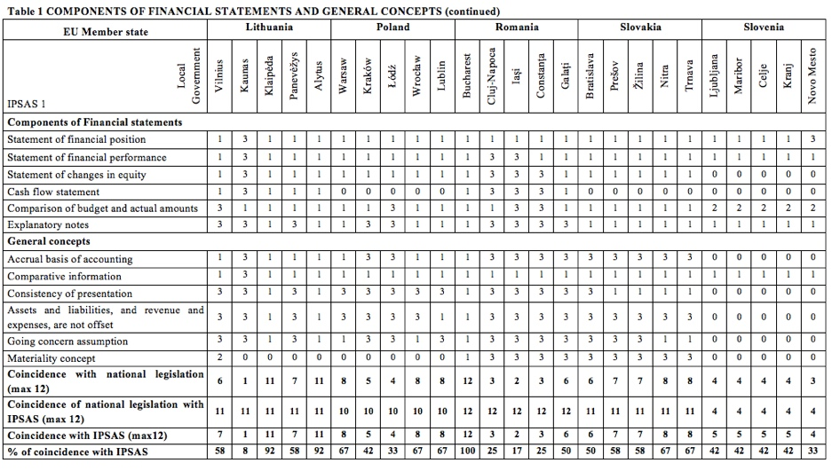
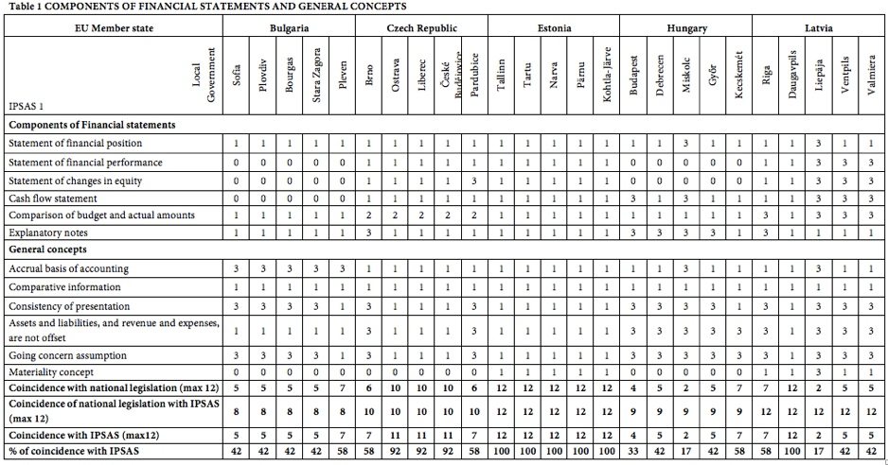

It is important to note that IPSAS 1 mandates the kind of budget information that must be presented. More precisely, IPSAS 1 and IPSAS 24 – Presentation of Budget Information in Financial Statements focus on a comparison between the budgets (original and final) and actual amounts expended. Therefore, governments are not required to present other types of budget information in order to be in compliance with the requirements of IPSASs. For example, the Municipality of Iasi (Romania) and the Municipality of Constanta (Romania), present budget information, but make no comparison. A cash flow statement is not required in Bulgaria, Poland, Slovakia and Slovenia. In Slovakia the information about cash flows is included in the Explanatory notes.
IPSAS 1 also outlines the General concepts on which the accounting information must be based, including the following: an accrual basis of accounting; comparative information; consistency of presentation; offsetting; going concern assumption; and the materiality concept. “Comparative information” is a concept that requires entities to disclose relevant and analogous information for the previous period. “Consistency of presentations” means that an entity shall not change its accounting policies from one period to the next unless the changes are made to assure fair presentation. The “Offsetting” concept obliges entities to present their assets, liabilities, revenues and expenses separately in the financial statements. The “Going concern” concept implies that the entity will continue its operations without ceasing in the foreseeable future. The materiality concept affects items whose individual value is not material; similar immaterial items could be aggregated and presented together in the financial statements.
The second section of Table 1 shows how local governments apply general accounting concepts. This information is taken from the Explanatory notes, except for the information about the materiality concept, which is taken mainly from the statement of financial position and the statement of financial performance. If a local government does not disclose in the Notes that it applies an accrual basis of accounting but the legislation requires it we assign the classification “3”. The legislation of all these countries, except for Slovenia, requires an accrual basis of accounting under the reforms adopted in those countries. However, in practice, in Bulgaria the focus is on cash accounting. As we can see from Table 1, the only concept required by Slovenian legislation is “comparative information”, which is the only obligatory concept in all Eastern EU countries. Offsetting of assets and liabilities, and expenses and revenues is explicitly prohibited in all countries except Slovenia. The materiality concept is required by national legislation only in Estonia, Latvia, Romania and Slovakia. The materiality concept cannot be applied in countries where the legislation imposes a template for financial statements (Bulgaria, the Czech Republic).
Furthermore, three compliance indexes have been calculated. The maximum value of the indexes is 12 because there are 12 variables. First, the index of coincidence with domestic legislation shows the extent to which local governments have complied with domestic legislation. Its value is calculated as a sum of the classifications “1”.
Table 2. Comparison of the indexes of coincidence
Value of the index | Index of coincidence with national legislation  (number of local governments) | Index of coincidence of national legislation with IPSAS  (number of local governments) | Index of coincidence with IPSAS  (number of local governments)
0 | 0 | 0 | 0
1 | 1 | 0 | 1
2 | 3 | 0 | 3
3 | 3 | 0 | 2
4 | 6 | 5 | 3
5 | 9 | 0 | 13
6 | 5 | 0 | 2
7 | 6 | 0 | 9
8 | 5 | 5 | 5
9 | 0 | 5 | 0
10 | 3 | 10 | 0
11 | 2 | 10 | 5
12 | 7 | 15 | 7
Mode of the indexes  (Most frequent value) | 5 | 12 | 5

The highest value in this index (12) is observed in Estonia where all local governments have presented their financial statements in compliance with legislative requirements. Second, the index of coincidence of national legislation with IPSAS 1 measures whether the domestic legislation complies with the requirements of IPSAS 1. It is calculated as a sum of the classifications “1” and “3”. The highest value of this index is obtained in three countries (15 local governments) and the lowest (4) is in Slovenia. Third, the index of coincidence with IPSASs describes the approximation of the information presented in the published GPFSs to the requirements of IPSASs. The value of the index is calculated as a sum of the classifications “1” and “2”. The highest value of this index (12) is again observed in Estonia.
In Table 2 the results are summarised in order to show the approximation to IPSAS. The table displays the values of the three indexes and their frequency in the sample. Lower values of the Index of coincidence with national legislation and of the Index of compliance with IPSAS are more frequent, revealing a lower level of compliance. In contrast to that, the values of the Index of coincidence of national legislation with IPSAS are higher, although only in 15 cases full coincidence is observed.

Conclusion
The general purpose financial statements are a primary source of financial information for external users. The increased public attention to governmental decisions and public resource management has resulted in greater demand for financial transparency and accountability, and subsequently has resulted in improved financial information. In this sense, the movement towards an accrual basis of accounting has been a key element of the reform process. Notwithstanding the fact that Eastern EU countries started from the same initial point in the early 90s, they have developed different public sector financial reporting systems and have reached different levels of implementation of accrual basis of accounting.
This study demonstrates that the domestic accounting legislation of only three of the countries studied (Estonia, Latvia and Romania) fully coincides with the requirements of IPSASs considering the twelve criteria chosen. Close to IPSASs compliance are the domestic legislation of the Czech Republic, Lithuania, Poland and Slovakia. The results show that the legislation of Bulgaria, Hungary and especially Slovenia differs significantly from IPSASs. The reason is that in these countries the cash basis of accounting still plays a dominant role. This study shows that seven local governments have complied with all national requirements and five of these are in Estonia. All local governments from the Czech Republic and Slovenia, and the municipality of Vilnius (Lithuania) present information that conforms more to IPSAS requirements than to national legislative requirements. The reason is that they voluntarily present financial information required by IPSAS 1. In any case, the results of this study show that further reforms towards full adoption of IPSASs are required in order to achieve a higher level of financial transparency in local governments.

References
Bathó Ferenc, Which Way Now? A Theoretical Programme for the Transition to Accrual-Based Accounting, 4 Public Finance Quarterly. 394, 411 (2012)
Chan James L., Government Accounting: An Assessment of Theory, Purposes and Standards, 23 Public Money and Management. 13, 20 (2003)
Duhovnik Meta, The Problems of Accounting in a Public Institution: The Case of Slovenia, 31 Financial Theory and Practice. 421, 445 (2008)
Ernst & Young, Overview and comparison of public accounting and auditing practices in the 27 EU Member States (2012)
Freed Larry, Quantifying the Impact of Transparency, Foresee Results’ E-Government Transparency Index (2011)
International Organisation of Supreme Audit Institutions, ISSAI 1200: Overall Objectives of the Independent Auditor and the Conduct of an Audit in Accordance with International Standards of Auditing, International Standards of Supreme Audit Institutions (2010)
International Public Sector Accounting Standards Board, International Federation of Accountants, International Public Sector Accounting Standard 1 – Presentation of Financial Statements, Handbook of International Public Sector Accounting Pronouncements (2011)
International Public Sector Accounting Standards Board, Recommended Practice Guideline: Reporting on the Long-Term Sustainability of an Entity’s Finances (International Federation of Accountants 2013)
International Public Sector Accounting Standards Board, The Conceptual Framework for General Purpose Financial Reporting by Public Sector Entities (International Federation of Accountants 2014)
Jaruga Alicja and Wojciech A. Nowak, Governmental Accounting in Transition: The Polish Experience, 11 Financial Accounting & Management. 75, 94 (1995)
Lakis Vaclovas and Laimute Kazlauskiene, Accounting Reform in Lithuania, Accounting Reform in Transition and Developing Countries 115-130 (Springer 2008)
Lamjav Navchaa, Accounting Systems and Structures in Poland, Accounting Reform in Transition and Developing Countries 131-138 (Springer 2008)
McKendrick Jim, Modernization of the Public Accounting Systems in Central and Eastern European Countries: The Case of Romania, 8 International Public Management Review. 168, 185 (2007)
Nistor Cristina S. and Crina I. Filip, The Evolution of Public Accounting in Romania in the Post-Communist Period, SSRN Electronic Journal (2008)
Nowak Wojciech A. and Barbara Bakalarska, Polish Public Sector Accounting in Transition: The Landscape after Early 1999 step in the State Redefining, International Comparative Issues in Government Accounting 265-278 (Springer 2001)
Pina Vicente, Lourdes Torres and Ana Yetano, Accrual Accounting in EU Local Governments: One Method, Several Approaches, 18 European Accounting Review. 765, 807 (2009)
Suhanyiova Alberta and Marian Gal, Reform of Slovak Accounting, Accounting Reform in Transition and Developing Countries 185-190 (Springer 2008)
Tanzi Vito, Corruption Around the World: Causes, Consequences, Scope, and Cures, IMF Working Paper (1998)
Žárová Marcela, Accounting Reform in the Czech Republic, Accounting Reform in Transition and Developing Countries 89-100 (Springer 2008)

Main Legislative Acts
European Union
Council Directive 2011/85/EU of 8 November 2011 on Requirements for Budgetary Frameworks of the Member States
Bulgaria
Accountancy Act (2006)
Instructions of Public Treasure Department in Bulgarian No 20/2004
Czech Republic
Law on Accounting 563/1991
Decree on Accounting 410/2009
Estonia
Accounting Law (2002)
General Rules for Public Accounting (2004)
Hungary
Act C of 2000 on Accounting
Government Decree 241/2000
Latvia
Law on Budget and Financial Management (2009)
Procedures for keeping accounting records (2009)
Lithuania
Law on Public Sector Financial Reporting (2011)
Public Sector Accounting and Financial Reporting Standards of Lithuania (2007)
Poland
Accounting Act (2005)
Act on Public Finance (2009)
Regulation on Accounting Rules (2009)
Romania
Accountancy Act 82/1991
Order 1917 on the Regulation of Public Sector Accounting (2005)
Slovakia
Act no. 431/2002 on Accounting
Regulation no. 639/2007 on Public Sector Financial Reporting
Slovenia
Law on Accounting (1999)
Rules on the Preparation of Annual Financial Reports for the Budget and other Entities (2002)

In this group we include (in alphabetical order): Bulgaria, the Czech Republic, Estonia, Hungary, Latvia, Lithuania, Poland, Romania, Slovakia and Slovenia.

